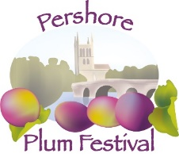
Pershore Abbey

CLASSIC CAR SHOW
August Bank Holiday Monday 26.8.2024

Site Access from 8.00am
Individual Car / Group Booking

Number of Cars
For multiple booking see overleaf
Model: |  | Reg. Number:
As a donation to Pershore Abbey, please follow a) or b):
- I enclose a cheque for £8 per car, payable to Pershore Abbey

- I have made a BACS Transfer of £8 per car to Pershore Abbey
Bank account name: PERSHORE PAROCHIAL CHURCH; Account number: 00695416
Barclays Bank Sort Code: 20 98 61
(Please use - CC your initial & your surname as reference on your BACS payment)
Enter Reference Code used here:
Name: | Address:
Contact Number: | Email:
Please return your completed application with cheque or with BACS Reference Code to: Pershore Abbey Classic Cars
11 Broad Street
Pershore WR10 1BB Tel : 07973464661
Please include a Stamped Addressed Envelope for your Show Pass and Directions (Passes will be sent out from July 2024)
Your personal Show Pass will be required for Entry to the Car Show
Cut off date for Booking is 31st July 2024

For further Information: Email: classiccars@pershoreabbey.org.uk
Thank you for your application, we look forward to welcoming you.

Car Register/Club/Group:…
Name | Model | Reg no. | Paid

DISCLAIMER
Car owners and all visitors to the car show are respectfully informed that the Plum Festival Organizer’s cannot accept responsibility or liability for theft, loss or injury on this site.
In the event of the show not going ahead due to adverse weather, no refund is payable.

